Functional Specifications
Document Information
Author | Girish S. Pai
Owner | Dominique Bonutto
Team | Sales and Distribution
Project Name | GSAP-SYNRJ: Consignments
Project Phase
Organizational Unit | Sales And Distribution, France
Status | Draft
Version | 0.1
Document Creation Date | 20-May-2008
Current Version Delivered Date

Document Review & Sign-off

Signatories
Role | Name | Status | Date
Business Responsible | Dominique Bonutto
Business Stream | Sales And Distribution
IS Engineer | Jerome Sourbet
IS Responsible Source System | Bruno Duschamp /SAP SD Production support
IS Responsible Target System | Jerome Sourbet
Functional Specification Responsible | Girish S. Pai
Interface Sign Off Responsible | Dominique Bonutto
PI/XI Implementation Responsible | Girish S. Pai

Reviewers
Role | Name | Comments Received | Date

Revision History
Version No. | Date | Author | Revision Description
1.1 | 27-06-2008 | Girish S. Pai | Updated test credentials and database update logic
1.2 | 03-10-2008 | Rosie Sasidharan | Added 2 extra fields in source structure, target structure and message mapping
1.3 | 09-10-2008 | Rosie Sasidharan | Added mapping logic for negative validation for 5 numeric fields
1.4 | 19-08-2009 | Rajesh Shanmugasundaram | Added 2 more fields as per chaRM 8000009096
1.5 | 09-10-2012 | Rohan Ivan D’Costa | Added the new field according to ChaRM 8000030236 and updated the mapping sheet

Other Related Documents
Unique ID | Related Document | Comment
 |  | High Level Design document

Definitions and Abbreviations
Term / Abbreviation | Definition / Description
Table of Contents
1 Introduction 5
1.1 Executive Summary 5
1.2 Purpose of this document 5
2 Overview and Scope 6
2.1 Functional Description 6
2.2 Dependencies / Constraints 6
2.3 Assumptions 6
2.4 Document Scope 6
3 Business Choreography 7
4 Detailed Functional Specifications 8
4.1 Requirement Background 8
4.2 Current Scenario 9
4.3 Business Process 10
4.4 Error & Alert Handling 10
5 Interface Specifications 12
5.1 Interface Process Flow Diagram 12
5.2 Proposed Transfer Method / Program 12
5.3 Target / Source Data Layout 12
5.4 Mapping fields to Source / Target 14
6 Involved Applications and Connectivity 15
6.1 Sender System(s) 15
6.2 Receiver Systems 17
6.3 Connectivity 19
7 Additional Requirements 20
7.1 Post Interface Activities 20
7.2 Legacy System Extract / Load Procedure 20
7.3 Network Integration 20
7.4 Reporting / Monitoring 20
7.5 Backup/Archiving 20
7.6 Security and Authorization 20
7.7 Reconciliation Procedures and Audit Requirements 21
7.8 Processing and Operational Considerations (Interface Specific) 21
7.9 Change Management Requirements 22
8 Non-Functional Requirements 23
8.1 Migration Requirements 23
8.2 Production Support Level 23
8.3 Transaction Volume 23
9 Testing Requirements 24
9.1 Key Business Test Conditions 24
9.2 Risk and Controls Test Conditions 24
9.3 Testing Considerations / Dependencies 24
10 Quality Risk Assessment 25
11 Appendix 26

Introduction

Executive Summary
The objective of the interface is to transfer the consignment related details like material data, orders, Invoices etc, which is created as single report in gSAP, needs to be sent to SYNRJ.

Purpose of this document
This document is used to describe the functional design of the interface GSAP_to_SYNRJ_Consignment. It aims to give an understanding why the interface is needed and detailed information about the functional requirements.

- Overview and Scope

Functional Description
The sales people at SYNRJ would like to have a view where they can see various details related like Order no, invoice number etc. Hence SYNRJ has requested GSAP for some new transactions to provide these details. The OASIS interface will upload the data generated from GSAP into SYNRJ database.

Dependencies / Constraints
- Requires patching of gSAP for enabling proxy settings. GSAP is currently on WebAS 6.2 and hence requires additional SP installation.

Assumptions
None

Document Scope
The scope of the document is to cover the Business requirement surrounding the stated functionality from an XI perspective.
- Business Choreography
Not applicable as there is only one message transfer in this particular interface in asynchronous mode.
- Detailed Functional Specifications

Requirement Background

GSAP_to_SYNRJ_Consignment

Short description | Consignment related data to be sent from gSAP to SYNRJ.
Business Area: | SD |  |  |  |  | Date: |  | 26-05-2008
Requested by: | Dominique Bonutto |  |  |  |  | Tel no:
New scenario | Yes No
Program type: | Batch interfaces Online interfaces
Priority: | High/mandatory Medium/recommended Low/optional
Business Impact  Results if no solution is created: |  |  |  | Legal requirements not fulfilled  Lack of essential business information  Lack of functions compared to legacy system  Others:
Is there an alternative in the standard system? |  |  |  | Yes No
Description of alternative: |  |  |  | As a temporary solution GSAP will send the data by files through mails
Reasons why alternative is not acceptable: |  |  |  | Performance problems Complexity  Others: Involves too much manual intervention and effort
Date of project management approval: |  | 26-05-2008 | Date of steering committee approval:

Current Scenario

This is a new request from business to have the consignment related data into SYNRJ.

Business Process

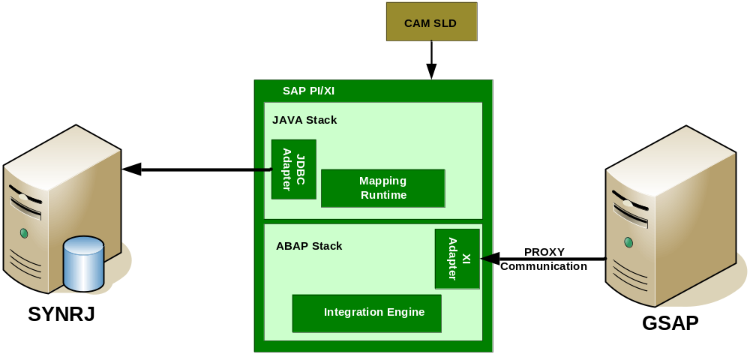

Error & Alert Handling

#1 Error description
Error case | Error connecting to GSAP system
Business critical?  (Business critical is interfaces, where the business impact is big (production flow, logistic flow etc.)) | No
How to check, if the message has been received correct? (Acknowledgement etc.) | NA
How to find errors? (how to monitor the process) | Through standard SAP PI monitoring tools
Who to contact, if there are any errors? | SAP BASIS for connection issue
What to do, if the interface fails? (restart procedures) | Correct the error and ask SAP SD production support to re-trigger the program.

#2 Error description
Error case | Error connecting to SYNRJ system
Business critical?  (Business critical is interfaces, where the business impact is big (production flow, logistic flow etc.)) | No
How to check, if the message has been received correct? (Acknowledgement etc.) | Verify data received from GSAP with the table
How to find errors? (how to monitor the process) | Through standard SAP PI monitoring tools
Who to contact, if there are any errors? | Jerome Sourbet
What to do, if the interface fails? (restart procedures) | Correct the error and ask SAP SD production support to re-trigger the program.

Interface Specifications

Interface Process Flow Diagram

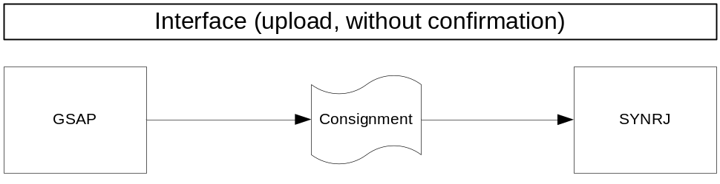

Proposed Transfer Method / Program
The inbound (into PI) interface is through SAP proxy communication.
The outbound (out of PI) interface is through JDBC adapter where PI updates the table at SYNRJ.

Target / Source Data Layout

Source Layout:
Field ID. | Table | Field Name | Field Description | Type | Size
 | VBAK | KUNNR | Sold to party
 | VBAK | NAME1 | Name of Sold to party
 | VBAK | STCODE | Ship to key
 | VBAK | ERDAT | Date (create on)
 | VBAK | AUART | Document type
 | VBAK | AUGRU | Order reason
 | VBAK | VBELN | Document number
 | VBAP | POSNR | Document Item
 | VBAP | MATNR | Material code
 | VBAP | ARKTX | Material Description
 | VBAP | LSMENG | Qty Ordered
 | VBAP | VRKME | Sales unit
 | VBAP | VGBEL | Reference Doc
 | VBAP | VGPOS | Ref Item
 | VBAP | NETPR | Net price
 | VBAP | WAERK1 | Curr.
 | VBAP | NETWR | Net Value
 | VBAP | WAERK2 | Curr.
 | VBAP | KZWI1 | Subtotal 1
 | VBAP | WAERK3 | Curr.
 | VBAP | KZWI6 | Subtotal 6
 | VBAP | WAERK4 | Curr.
 | VBAP | EDATU
 | VBUP | LFSTA | Delivery status
 | VBFA | RFMNG | The quantity already delivered

Target Layout:
Field ID. | File Name / Table | Field Name | Field Description | Type | Size
 | LOAD_CONSIGNMENT | S_SOLD_TO_PARTY |  | char | 10
 | LOAD_CONSIGNMENT | S_NAME1 |  | char | 40
 | LOAD_CONSIGNMENT | SHIP_TO_CODE |  | char | 10
 | LOAD_CONSIGNMENT | S_CREATE_DATE |  | char | 8
 | LOAD_CONSIGNMENT | S_DELIV_DATE |  | char | 10
 | LOAD_CONSIGNMENT | S_TYPE_DOC |  | char | 4
 | LOAD_CONSIGNMENT | S_ORDER_REASON |  | char | 3
 | LOAD_CONSIGNMENT | S_NUM_DOC |  | char | 10
 | LOAD_CONSIGNMENT | S_ITEM_DOC |  | char | 6
 | LOAD_CONSIGNMENT | N_MATERIAL_COD |  | numeric | 18
 | LOAD_CONSIGNMENT | S_MATERIAL_DESC |  | varchar | 40
 | LOAD_CONSIGNMENT | N_QTY_ORDERED |  | decimal | 15,2
 | LOAD_CONSIGNMENT | S_SALES_UNIT |  | char | 3
 | LOAD_CONSIGNMENT | S_DOC_REF |  | char | 10
 | LOAD_CONSIGNMENT | S_ITEM_REF |  | char | 6
 | LOAD_CONSIGNMENT | N_NET_PRICE |  | decimal | 11,2
 | LOAD_CONSIGNMENT | S_CURRENCY_1 |  | char | 5
 | LOAD_CONSIGNMENT | N_NET_VALUE |  | decimal | 15,2
 | LOAD_CONSIGNMENT | S_CURRENCY_2 |  | char | 5
 | LOAD_CONSIGNMENT | N_SUBTOTAL1 |  | decimal | 13,2
 | LOAD_CONSIGNMENT | S_CURRENCY_3 |  | char | 5
 | LOAD_CONSIGNMENT | N_SUBTOTAL6 |  | decimal | 13,2
 | LOAD_CONSIGNMENT | S_CURRENCY_4 |  | char | 5
 | LOAD_CONSIGNMENT | S_DELIVERY_STATUS |  | char | 1
 | LOAD_CONSIGNMENT | N_QUANT_DELIVERED |  | Decimal | 15

Mapping fields to Source / Target

Destination Element | Mapping Rule / Source Element | Condition
S_SOLD_TO_PARTY | KUNNR | No Primary key constraints new record to be added in the table for every record from GSAP
S_NAME1 | NAME1
SHIP_TO_CODE | STCODE
S_CREATE_DATE | ERDAT
S_DELIV_DATE | EDATU
S_TYPE_DOC | AUART
S_ORDER_REASON | AUGRU
S_NUM_DOC | VBELN
S_ITEM_DOC | POSNR
N_MATERIAL_COD | MATNR
S_MATERIAL_DESC | ARKTX
N_QTY_ORDERED | LSMENG | *Negative validation to be done
S_SALES_UNIT | VRKME
S_DOC_REF | VGBEL
S_ITEM_REF | VGPOS
N_NET_PRICE | NETPR | *Negative validation to be done
S_CURRENCY_1 | WAERK
N_NET_VALUE | NETWR | *Negative validation to be done
S_CURRENCY_2 | WAERK
N_SUBTOTAL1 | KZWI1 | *Negative validation to be done
S_CURRENCY_3 | WAERK
N_SUBTOTAL6 | KZWI6 | *Negative validation to be done
S_CURRENCY_4 | WAERK
S_DELIEVRY_STATUS | LFSTA
S_QUAT_ORDERED | RFMNG | *Negative validation to be done

*Negative validation to be done - Values coming with negative at the end as a suffix should be converted with negative at the beginning as a prefix (for eg: incoming field value “123-“ should be converted to “-123” while being inserted to table since this is the negative format accepted by Database). There will be no change done in the field values that come as positive values.
- Involved Applications and Connectivity

Sender System(s)

#1 (Sending Business System)
Sending Business System (incl. Location): | GSAP, Basel
Leading System for this message: | No Yes
System owner/contact person: | Bruno Duchamp
What is the trigger for sending of messages? | Scheduled job at GSAP
How to restart in case of errors? | SAP Production support to re-trigger the job
Description of release/update cycle of the sending system: | To be clarified from Basis

#1 Sending message (Sending Business Document)
Reference to Common Data Model | NA
Message type: (file/IDOC/XML/DataBase/Others) | XI Standard SOAP XML
Description Message Content: | Consignment
Key fields identifying this message | Combination of VBAK-KUNNR, VBAK-VBELN and VBAP-POSNR
Message size (Minimum/Average/Maximum) : | Max 500KB
Message Rate / Time Unit (Minimum/Average/Maximum): | Avg -50records/day  Max -100 records/day
Frequency: | Daily Weekly Monthly  Biweekly Others:
Message Scheduling | Exact schedule to be confirmed
Peak | No  Yes Detail:
Packaging | No  Yes,  Package description:
Message structure description created with: | SAP Standard interface  Export from middleware  Others (e.g. XMLSpy)
Message layout: Refer section 5.3

#1 Mapping Service
Is mapping needed (transformation from the sending to the receiving message) ? | Yes
General description of the transformation: | One-One
Source Message (s): | Proxy, XI SOPA XML
Target Message (s): | Database Table
Mapping description: Refer section 5.4

#1 Routing Rules {if necessary per system})
What are the routing criterias for the receiving system? | All messages received from sending system needs to be sent to receiving system
In case not all data is send, describe what data is send to receiving system? | All data is sent
#1 Message Name
Message Layout:
Sending field | Value | Include/exclude receiving system

Receiver Systems

#1 Receiving system (Integration Server -> Receiving Business System)
Receiving Business System (incl. Location): | SYNRJ, France
System owner/contact person: | Bernard Stepien
Leading System for this message? | No Yes
How to restart in case of errors? | SAP to re-trigger the job to send the data
How is the processing of the message  triggered? | Scheduled job at GSAP

#1 Receiving message (Receiving Business Document)
Message type: (file/IDOC/XML/DataBase/Others) | Database
Description Message Content: | Same as sender system
Message size (Minimum/Average/Maximum) : | Same as sender system
Message Rate / Time Unit (Minimum/Average/Maximum): | Same as sender system
Frequency: | Daily Weekly Monthly  Biweekly Others:
Message Scheduling | At SYNRJ end it is an online data transfer as we receive the data from GSAP.
Peak | No  Yes Detail:
Packaging | No  Yes,  Package description:
Message Structure created with: | SAP Standard interface  Export from middleware  Others (e.g. XMLSpy)
Message layout: Refer section 5.3

Connectivity
GSAP System | Development | Integration | UAT | Staging | Production
System ID | E1B | I1B | U1B | Q1B | P1B
Client | 010 | 010 | 010 | 010 | 010
Appserver (Hostname) | sape1b.cp.chbs | sapi1b.cp.chbs | sapu1b.cp.chbs | Sapq1b.cp.chbs | sapp1b.cp.chbs
System Number | 01 | 02 | 00 | 01 | 00
Gateway | sapgw01 | sapgw02 | sapgw00 | sapgw01 | sapgw00
Type
Location / Site | HP Wallstrasse-RZ | HP Wallstrasse-RZ | HP Wallstrasse-RZ | HP Wallstrasse-RZ | HP Wallstrasse-RZ
User | available | Available | available | available | available
Password | available | Available | available | available | available
System Role | Message Source

SYNRJ Server | Development | Integration | UAT | Staging | Production
hostname | FRSCSQL2K04 | FRSCSQL2K04 | FRSCSQL2K04 | FRSCSQL2K04 | FRSCSQL2K03
Database Name | BD_SYNRK | BD_SYNRK | BD_SYNRK | BD_SYNRK | BD_SYNRK
Table Name | LOAD_CONSIGNMENT | LOAD_CONSIGNMENT | LOAD_CONSIGNMENT | LOAD_CONSIGNMENT | LOAD_CONSIGNMENT
Interface Technology/Port | SQLServer/1433 | SQLServer/1433 | SQLServer/1433 | SQLServer/1433 | SQLServer/1433
Site | France | France | France | France | France
User name | OASIS_test | OASIS_test | OASIS_test | OASIS_test | OASIS
Password | available | available | available | available | available
System Role | Message Destination

- Additional Requirements

Post Interface Activities
None from PI point of view.
Once the data is uploaded at SYNRJ LOAD_CONSIGNMENT table, a job at SYNRJ will run at 04:00CET to pick the records from LOAD_CONSIGNMENT table and post it to other main tables. Once upload is complete the records from LOAD_CONSIGNMENT table are deleted.

Legacy System Extract / Load Procedure
None

Network Integration
Not Applicable

Reporting / Monitoring
None

Backup/Archiving
Standard Backup/Archiving process to be followed.

Security and Authorization

Security Requirements
Are there any restrictions on who can see the content of the interface data in the integration system? | No
Does the integration process exceed the boundaries of the Syngenta network? | yes no
If yes how is security ensured? | Not Applicable
Is the integration process aligned with the Syngenta data protection department | yes no
Whether message Payload needs to be encrypted such that it is not visible for administrators? | No

Reconciliation Procedures and Audit Requirements

Approach
Not applicable

Metrics
Not applicable

Processing and Operational Considerations (Interface Specific)

Performance
None

Batch Requirements
Detail to be received from SAP.

Data Maintenance Requirements
None

Re-Use Details
None

Multi-Company, Multi-Jurisdiction Considerations
None

Other
None

Change Management Requirements
No special requirements

- Non-Functional Requirements

Migration Requirements
None

Production Support Level
Standard support level expected

Transaction Volume
Maximum of 500KB/day

- Testing Requirements

Key Business Test Conditions

ID | Condition | Expected results | Cycle Reference | Sample Data
1 | Trigger the records from GSAP | All the records need to be uploaded into SYNRJ database

Risk and Controls Test Conditions
ID | Condition | Expected results | Cycle Reference | Sample Data
 | None

Testing Considerations / Dependencies
None
- Quality Risk Assessment
none.
- Appendix

Related Documents:
Doc-ID | Document Name

Open Issues
No. | Date | Owner | Description | Status
1 | 03-06-2008 | Girish S. Pai | Agree a time plan on patching of GSAP required for proxy communication | In-progress

